1. Briefly describe the MVC pattern.

Standing for Model, View, controller helps you create and app that is more testable and easier to update then a more monolithic app (one piece).

Model: classes that represent the data of the app.

View: Displays the information of the model

Controllers. Handles all logic behind the actions of the user.

1. Which part of MVC handles each of the following?

User Interface logic – View

Input logic – Controller

Business logic – Model

1. What is meant by an HTTP endpoint, and give an example of one from your favorite website?

Is a targetable URL. This can have parmaters to get into someones account.

<http://www.koalastothemax.com/>

1. Given this website address, [http://catalog.indianhills.edu/ atoid=44catoid=44](http://catalog.indianhills.edu/index.php?catoid=44), answer the following:

What is the protocol? atoid=44

What is the target URI http://catalog.indianhills.edu/

What is the parameter? atoid=44

1. What is the default routing logic used by MVC?

/[Controller]/[ActionName]/[Parameters]

1. Where is the routing format actually specifed?

app.UseEndpoints(endpoints =>

{

endpoints.MapControllerRoute(

name: "default",

pattern: "{controller=Home}/{action=Index}/{id?}");

});

1. What is the purpose of HtmlEncoder.Default.Encode?

To protect the app form malicious input

1. Using the revised Welcome method as an example, add a new method to the Home Controller called CalcSum. This method should have two integer parameters, and should use optional parameter values of your choice. The method should return the sum of the two numbers back to the brower, such as Sum is xx. Screen shot the code AND of your browser showing it works.

[/HelloWorld/CalcsSum?inta=2&intb=3](https://localhost:44322/HelloWorld/CalcsSum?a=2&b=3)

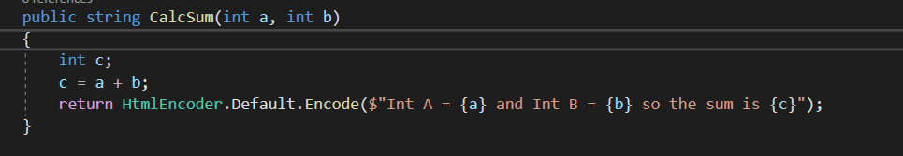

1. Do your URL parameters have to be passed in the same order as the method defines them?

No

1. What allows the named parameters in the URL to map to the corresponding method parameters?

The action name part of the url